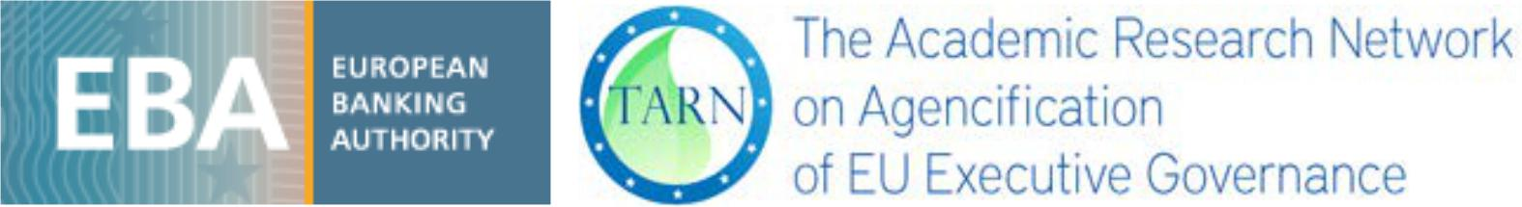

Financial Regulation, the Banking Union and the European Banking Authority: Lessons for the Future

 | EBA-TARN Conference
 | 18 - 19 June 2018
 | European Banking Authority, London
 | Preliminary programme
 | Monday 18 June 2018
09.00 – 09.30 | Registration & coffee
 | Welcome
09.30 – 09.45 | Opening, Andrea Enria, Chairperson of EBA
09.45 – 10.00 | Introduction to the Sessions, Despina Chatzimanoli, Legal Unit, EBA
 | Session I: Challenges Ahead for the EBA (10.00 – 12.30)
 | Chair: Jonathan Overett Somnier, EBA
10.00 – 10.30 | Brexit and European Agencies, Michael Dougan, Liverpool University
10.30 – 11.00 | The Banking Union and the Single Market, Rosa Maria Lastra, Queen
 | Mary University of London

 | 11.00 – 11.30 Coffee break
11.30 – 12.00 | Brexit and the ESA’s review, Christos Hadjiemmanuil, Bank of Greece
 | and University of Piraeus
12.00 – 12.30 | Discussion

12.30 – 14.00 Lunch

Session 2: Challenges Ahead for Financial Services and their Governance (14.00 – 17.00)

Chair: Mina Philippa, ESMA (TBC)

14.00 – 14.30 | ‘Rating’ ESMA’s Accountability: ‘AAA’ Status, Jonathan Foster,
 | Counsel, Barrister - formerly Senior Legal Officer and sometime Independent Investigating Officer at ESMA
14.30 – 15.00 | Becoming a Powerful Regulator: The European Securities and Markets
 | Authority (ESMA) in European Financial Sector Governance, Aneta
 | Spendzharova, Maastricht University
15.00 – 15.30 | Procedural Rule-Making of European Supervisory Agencies: An
 | Effective Tool for Legitimacy? Maurizia de Bellis, University of Rome
 | Tor Vergata
 | 15.30 – 16.00 Coffee break
16.00 – 16.30 | EBA and Meroni 2.0, Andreas Orator, University of Vienna
16.30 – 17.00 | The Independence of EU Agencies from EU Political Institutions in the
 | Field of Financial Services, Matteo Ortino, University of Verona
17.00 – 17.30 | Discussion
19.00 | Dinner with speakers

Tuesday 19 June 2018

Session 3: Supervising the Supervisors: Accountability of ESA’s and ECB (09.00 – 13.00)

Chair: Ellen Vos, Maastricht University

09.30 – 10.00 | Keeping Up with the Times: New Accountability of EU Financial
 | Supervisors, Despina Chatzimanoli, EBA
10.00 – 10.30 | The ECB’s Accountability in the Post-Banking Union Era, Diane
 | Fromage, Maastricht University
10.30 – 11.00 | Lessons on EU Financial Regulation from TARN, Michelle Everson,
 | Birkbeck College
11.00 – 11.15 | Discussion

11.15 – 11.30 Coffee break

Session 4: TARN: Lessons and Future Agenda (11.30 – 13.00)

Chair: TBC

11.30 – 11.45 | Constitutionality, Powers, and Legitimacy of EU Agencies, Maurizia de
 | Bellis, University of Rome Tor Vergata
11.45 – 12.00 | External Dimension of EU Agencies and Bodies, Merijn Chamon, Ghent University
12.00 – 12.15 | EU Agencies: Problem-Solving, Performance and the Accountability
 | Overload: Squaring the Impossible Circle? Michelle Everson, Birkbeck
 | College

12.15 – 13.00 | Discussion
 | Closing
13.00 – 13.15 | TARN 2.0: TARN’s Research Agenda for 2018-2021, Ellen Vos,
 | Maastricht University and Michelle Everson, Birkbeck College
13.15 – 13.30 | Adam Farkas, Executive Director of EBA

