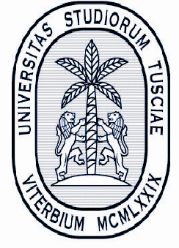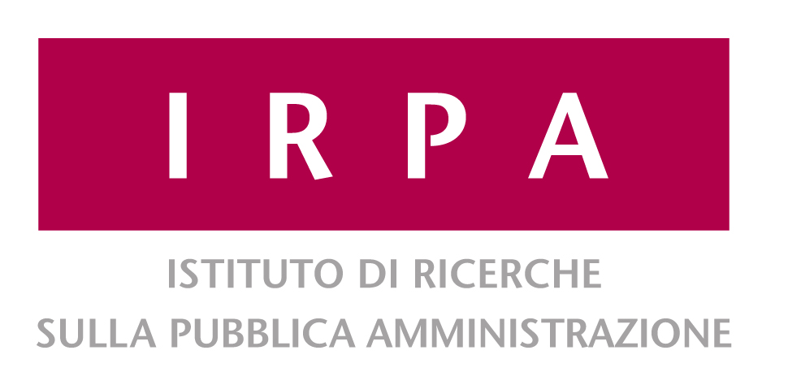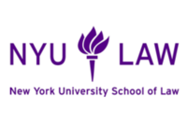 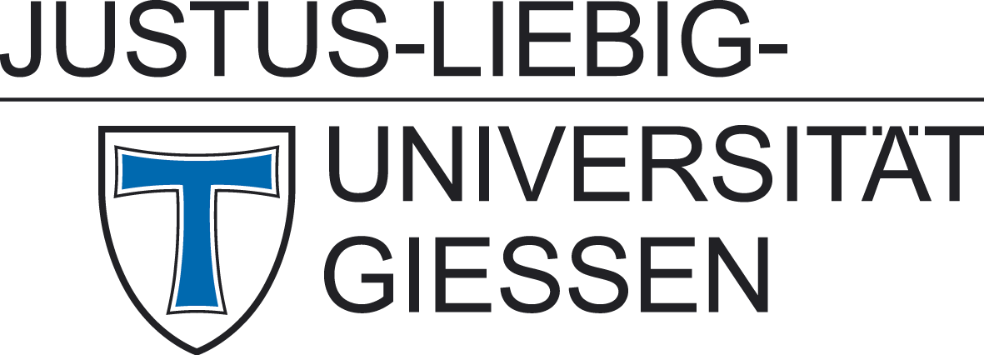

10th Global Administrative Law Seminar

**GAL 10th Anniversary**

–

**Law and Global Governance of Development**

Viterbo, 12-13 June 2014

Università «La Tuscia»

Rettorato – Aula Magna

Via di Santa Maria in Gradi, 4

**GAL 10th Anniversary**

Thursday June 12th, 2014

14:00 Welcome

**14:10 Ten Years of GAL: Has GAL Grown Up?**

Sabino Cassese *(Italian Constitutional Court)*

Joseph H.H. Weiler *(European University Institute)*

Richard B. Stewart *(NYU School of Law)*

Benedict Kingsbury *(NYU School of Law)*

Christoph Möllers *(Humboldt-Universität zu Berlin)*

Viterbo Group

*16:40 Coffee Break*

17:00 General Discussion

**18:15 The Future of GAL**

*Chair: Sabino Cassese (Italian Constitutional Court) and Richard Stewart* *(NYU School of Law)*

Gal Project: Research in Progress, Agenda and Next Steps

**19:00 Law and Development: Informal Introductory Meeting**

*Chair: Philipp Dann (Giessen University), Kevin Davis (NYU School of Law) and Benedict Kingsbury**(NYU School of Law)*

*20:00 Dinner*

**Law and Global Governance of Development**

Friday, June 13th 2014

**9.00 First Session: Effectiveness and Accountability**

*Chair: Philipp Dann (Giessen University)*

Giedre jokubauskaite, *(Edinburgh Law School)*

Accountability of multilateral development banks: How useful is GAL approach?

marie Guimezanes *(Toulouse University)*

States and NGOs: Virtuous Circle of Aid Effectiveness?

Maninder Malli *(NYU)*

Institutional Capacity in World Bank Program-for-Results financing

9:30 Discussant:

Sarah Dadush *(Rutgers University)*

9:45 General discussion

*10:15 Coffee break*

**10:30 Second Session***:* **Role of Law**

*Chair: Benedict Kingsbury* *(NYU School of Law)*

Adrian Di Giovanni *(International Development Research Centre Ottawa, Canada)*

Link between Law and Development – and the Regulation of Development

Deval Desai (*Research Associate, School of Oriental and African Studies)*

Context as an Organizing Principle for the Rule of Law Field

Franz Christian Ebert (Max-Planck Institute for Comparative Public Law & International Law)

Public Law Approach to Development Governance: World Bank’s Country Assistance Strategy

11:00 Discussant:

Kevin Davis *(NYU School of Law)*

11:15 General discussion

*11:45 Coffee break*

**12:00 Third Session***:* **Rights and Bargaining Power**

*Chair: Kevin Davis (NYU School of Law)*

Qingxiu Bu  *(University of Sussex)*

Anatomy of Chinese Multinational’s Behavior: Human Rights Perspective

Michael Akomaye Yanou *(University of Buea)*

Land Rights Model in Cameroon

Tinenenji Banda *(Cornell University)*

Legal Aid and Extractive Contracting in Africa

12:30 Discussant: Isabel Feichtner *(University of Frankfurt)*

12:45 General discussion

*13.15 Light lunch*

**14:15 Fourth Session: International Cooperation, Local Consequences**

*Chair: Sarah Dadush* *(Ruttgers University)*

Maria Cecilia da Silva Oliveira *(Columbia University)*

Security Apparatus and Sustainable Development in Brazil

Diliana Stoyanova (*University of Helsinki)*

WTO-IMF-World Bank Cooperation

Erica Hovani *(Legal Counsel for the African Risk Capacity Agency)*

Disaster Response Financing of African Risk Capacity

14:45 Discussant: Michael Riegner *(Giessen University)*

15:00 General discussion

**15:30 Law and Global Governance of Development: Conclusions**

*Philipp Dann (Giessen University)*

*Kevin Davis (NYU School of Law)*

**16:00 End of Seminar**

For more information:

viterbogalseminar@gmail.com