Call for Papers

Symposium
Simplification of local administration in
Europe. Levels and dimensions.

30-31 October 2014
Bologna

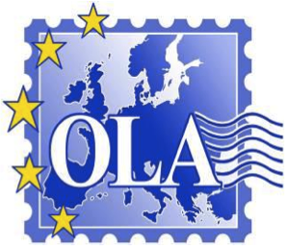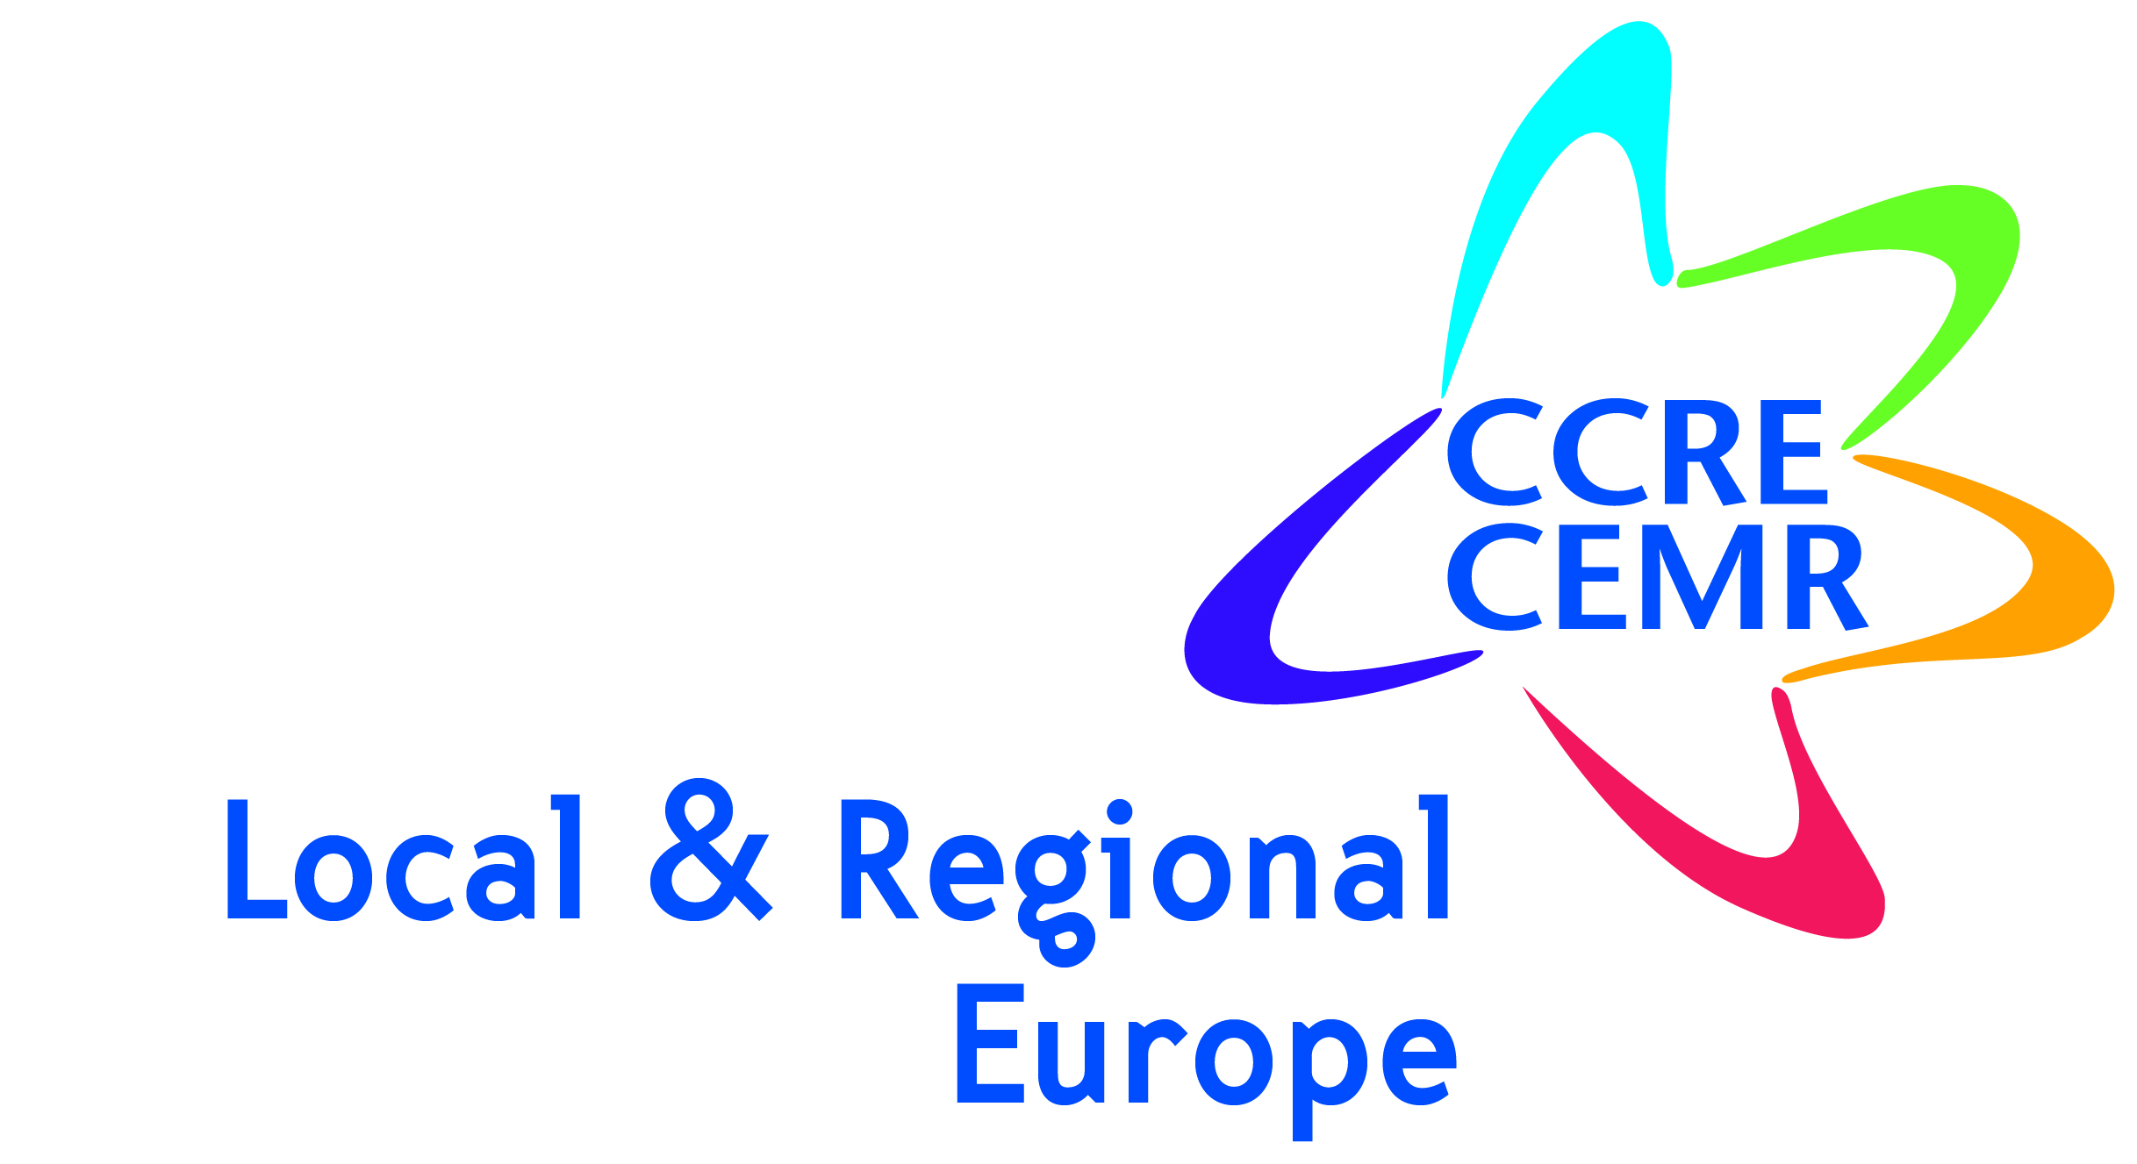

Symposium
Simplification of local administration in
Europe. Levels and dimensions.

Bologna, 30-31 October 2014
Call for Papers
The economic crisis has had a significant impact on the administrative organisation of the different European Union (EU) member states. In particular, it has affected the process and the reasoning behind resource allocation at the regional and/or local level.

Moreover, the crisis has reinforced the responsibility of member states, which have became the direct intermediaries of the EU in its effort to meet economic stability and growth objectives. These evolutions have led to a state in which decisions related to public matters are being centralised at the national level.

Against this background, a general renewal of the institutional and territorial framework can be observed. Public authorities are experimenting new measures which combine different levels of governments or aggregate and foster cooperation between local governments. Policies are being put into place which aim to reduce the number of regional and local entities responsible for providing public services (such as in-house or semi-public companies).

Under the pressure of the Stability and Growth Pact, many European states are therefore reforming the territorial and administrative organisation of their various government levels (communes, provinces, regions, etc).

The Italian team from Bologna University and OLA (Observatory on Local Autonomy), in collaboration with CEMR (the Council of European Municipalities and Regions) is organising a two-day symposium on this topic on 30 and 31 October 2014.

The symposium will be held in Bologna, at SPISA (Public Administration Studies Specialisation School of Bologna University), http://www.spisa.unibo.it/SPISA/Scuola/dovesiamo/default.
The conference organisers will cover expenses related to the accommodation and meals of all selected speakers. Participants will be responsible for travel expenses.

Papers dealing with the following questions are particularly welcome:
- What has been the impact of the economic crisis in your country?
- More specifically, what impact has there been on regional and local organisation?
- Are any reforms already being undertaken or about to be implemented?
- Do these reforms modify the levels and/or dimension of territories as well as the respective levels of government?
- What is the impact on citizens, businesses, and the administration?
- Do they introduce new (or modify existing) forms of cooperation, fusion or aggregation of local governments?
- What measures are being taken concerning entities which provide public services (particularly private or semi-public ones), as well as shared-service partnerships or cooperations between different public entities (public-public cooperation)?
- Have other forms of cooperation emerged (e.g. with the service sector or volunteers)?
Submission
Proposals should be submitted no later than 15 april 2014 to Ms Line Salmon-Legagneur: line.salmon-legagneur@univ-lille2.fr.
Notification of acceptance will be sent by email by 19 May 2014.
The proposal must include a provisional title, an abstract and 5 keywords (see the template below).The abstract must be written in English or French, and is limited to 2000 characters (excluding spaces). Please indicate the name(s) of the author(s), as well as their research institution(s) and email address.
Steering Committee
Prof L.Vandelli, Prof C.Tubertini, Dr. M. De Donno, Dr. S.Guérard, Dr. M.Dreyfus, Dr. A.Poth-Mögele
For any further information, please contact:
Mme Line Salmon-Legagneur, line.salmon-legagneur@univ-lille2.fr
OLA-CERAPS, Université Lille 2, 1, Place Déliot, BP 629, 59024 Lille - France
Tel.: +33 (0)3 20 90 76 34
Fax: +33 (0)3 20 90 77 00
Website: http://www.ola-europe.com/
Paper Proposal
Simplification of local administration in
Europe. Levels and dimensions.
Bologna (Italy), 30-31 October 2014

Contact details
Surname:
First name:
University / Institution:
Email address:
Telephone:
Postal address:

Provisional Title

Keywords: (5)

Abstract
- English or French
- 2000 characters maximum (spaces excluded)

