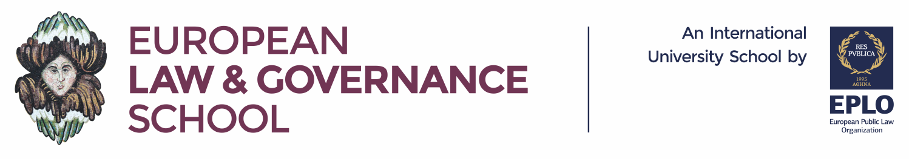

PRESS RELEASE
June 27, 2018

6 Scholarships for Europe’s future Italian leaders

The Ministry of Foreign Affairs of the Italian Republic offers 6 scholarships for Italian students seeking to pursue postgraduate degrees at the European Law and Governance School (ELGS).

The ELGS offers unique interdisciplinary programs in the fields of law, political science and public administration (governance) with international renowned faculty, global networking and multilingual research.

Eligible degrees include two taught degrees, the LLM in EU Law and the MA in Governance, and the research-based Master of Studies. The LLM program focuses on key issues of the EU law and policy. The MA degree teaches intricacies of European integration, international institutions and globalization. The Master of Studies facilitates independent research in Legal studies, Governance studies, or in an interdisciplinary topic.

We are currently accepting applications for Session 2018/19. Classes start on October 15, 2018. Prospective students should apply online and state their reasons for requesting a scholarship in the relevant part of the online application form.

Info:
- https://www.elgs.eu/6-scholarships-for-italian-nationals/
- https://www.esteri.it/mae/it/servizi/italiani/opportunita/di_studio/european-public-law-organization.html



